**Jaypee Institute of Information Technology**

**Database Systems & Web (15B11CI312)**

**Tutorial 10 & 11 (Normalization)**

Q1. Suppose you are given a relation R(A,B,C,D). For each of the following sets of FDs, assuming they are the only dependencies that hold for R, do the following: (a) Identify the candidate key(s) for R. (b) State whether or not the proposed decomposition of R into smaller relations is a good decomposition and brieﬂy explain why or why not.

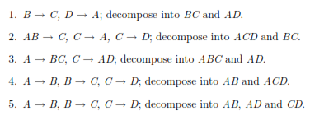

Solution:

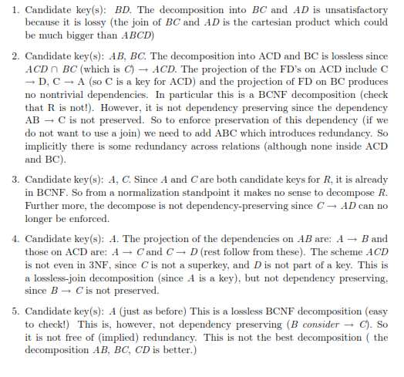

Q5. Consider the following collection of relations and dependencies. Assume that each relation is obtained through decomposition from a relation with attributes ABCDEFGHI and that all the known dependencies over relation ABCDEFGHI are listed for each question. (The questions are independent of each other, obviously, since the given dependencies over ABCDEFGHI are diﬀerent.) For each (sub)relation: (a) State the strongest normal form that the relation is in. (b) If it is not in BCNF, decompose it into a collection of BCNF relations.

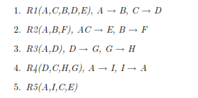

Solution:

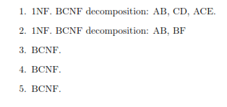

Q6. Suppose you are given a relation R with four attributes ABCD. For each of the following sets of FDs, assuming those are the only dependencies that hold for R, do the following: (a) Identify the candidate key(s) for R. (b) Identify the best normal form that R satisﬁes (1NF, 2NF, 3NF, or BCNF). (c) If R is not in BCNF, decompose it into a set of BCNF relations that preserve the dependencies.

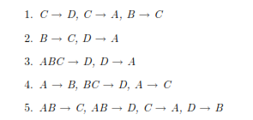

Solution:

